**5. REACTJS – HOL**

**Cohort Dashboard – React App Setup using CSS Modules and Inline Styles**

**STEP 1: Open App.js**

studentapp/src/App.js

**STEP 2: Replace Code in App.js**

Type the following code into App.js:

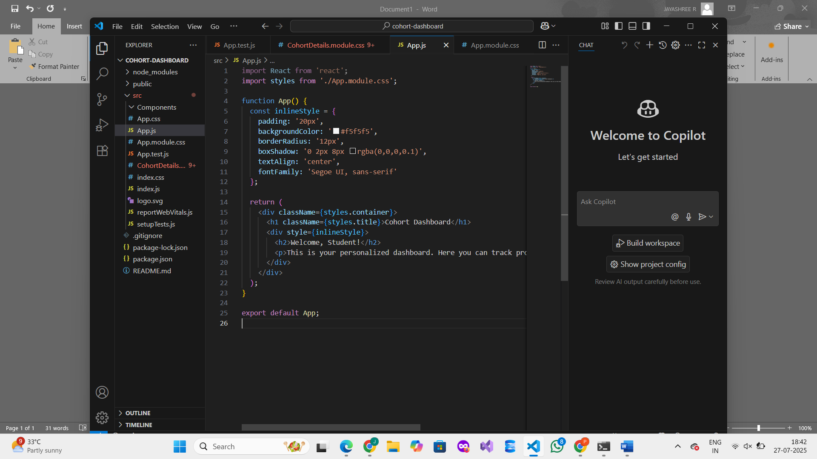

**STEP 3: Create CSS Module**

In the same src folder, create a new file:

App.module.css

Type the following CSS inside it:

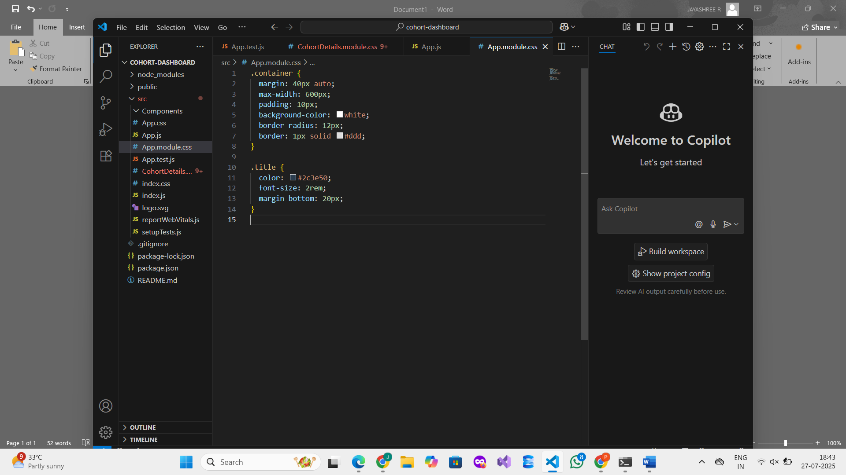

**Step 4: Save Word File**

1. Click File > Save As.
2. Choose the location.
3. Name the file:

CohortDashboardReact.docx

1. Click Save**.**

**OUTPUT :  
